**DAILY ONLINE ACTIVITIES SUMMARY**

|  |  |  |  |  |  |  |  |  |
| --- | --- | --- | --- | --- | --- | --- | --- | --- |
| **Date:** | **22/05/2020** | | | | | **Name:** | **Veekshith shetty** | |
| **Sem & Sec** | **8th B** | | | | | **USN:** | **4AL16CS097** | |
| **Online Test Summary** | | | | | | | | |
| **Subject** | | **BDA 2** | | | | | | |
| **Max. Marks** | | **40** | | **Score** | | | **27** | |
| **Certification Course Summary** | | | | | | | | |
| **Course** | **AWS** | | | | | | | |
| **Certificate Provider** | | | **Amazon** | | **Duration** | | | **60 min** |
| **Coding Challenges** | | | | | | | | |
| **Problem Statement:**  **prob1:**Find the number that is missing from the array containing n distinct numbers taken from 0,1,2…n | | | | | | | | |
| **Status: Solved** | | | | | | | | |
| **Uploaded the report in Github** | | | | | **Yes** | | | |
| **If yes Repository name** | | | | | [Veekshithshetty](https://github.com/Veekshithshetty)/[codingpart](https://github.com/Veekshithshetty/codingpart) | | | |
| **Uploaded the report in slack** | | | | | **Yes** | | | |

Online Test Details:

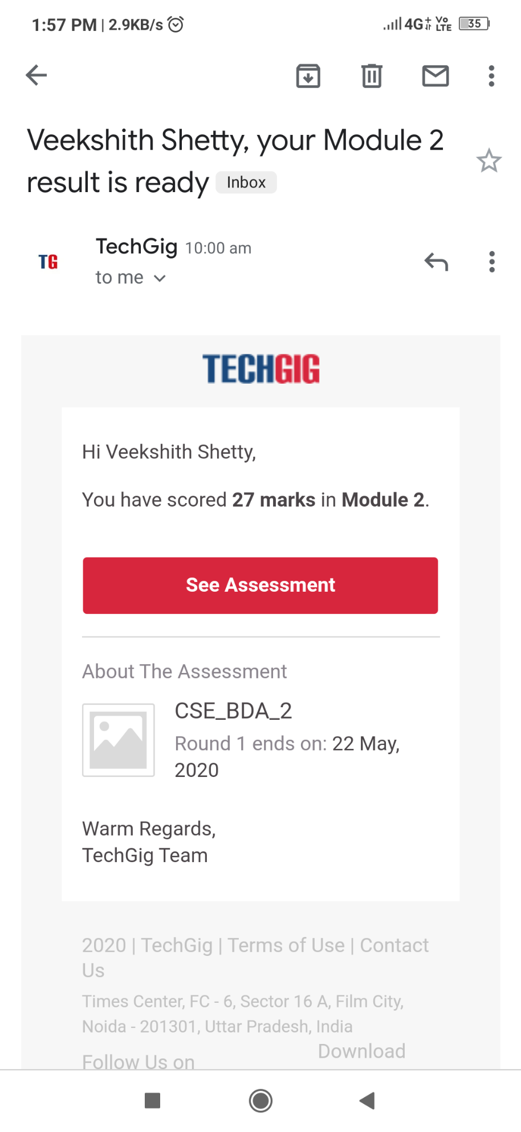

Certification Course Details:

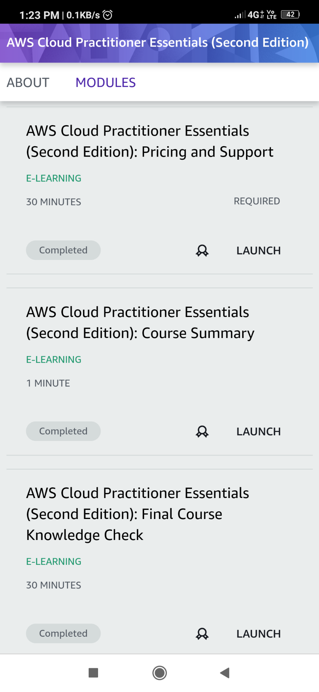

Coding Challenges Details:

Program 1:

**#include stdio.h**

**int getMissingNo(int a[], int n)**

**{**

**int i, total;**

**total = (n + 1) * (n + 2) / 2;**

**for (i = 0; i < n; i++)**

**total -= a[i];**

**return total;**

**}**

**int main()**

**{**

**int a[] = { 1, 2, 4, 5, 6 };**

**int miss = getMissingNo(a, 5);**

**printf("%d", miss);**

**getchar();**

**}**